**PROJECT DEVELOPMENT PHASE**

**PHASE SPRINT 2**

| **Date** | **07 November 2022** |
| --- | --- |
| **Team ID** | **PNT2022TMID13205** |
| **Project Name** | **Ai Based Discourse For Banking Industry** |
| **Maximum Marks** | **8 Marks** |

**Account Creation**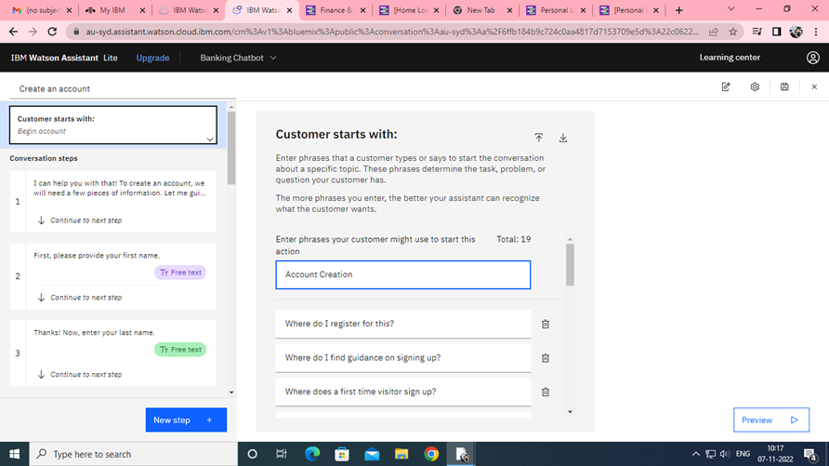

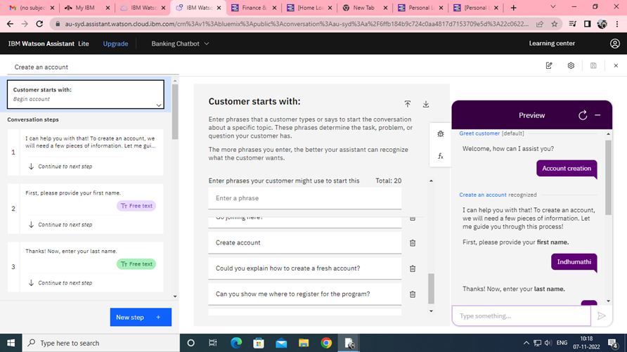

**Creation of Net Banking**

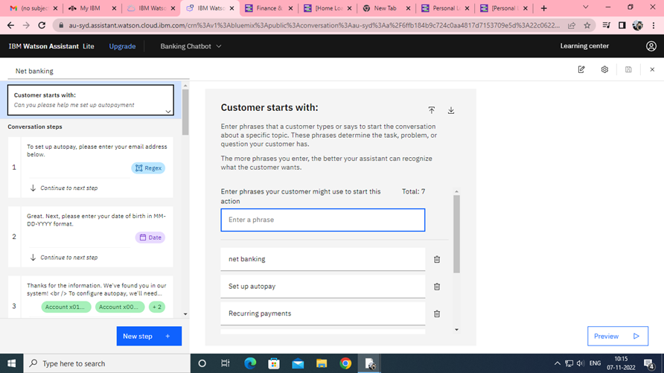

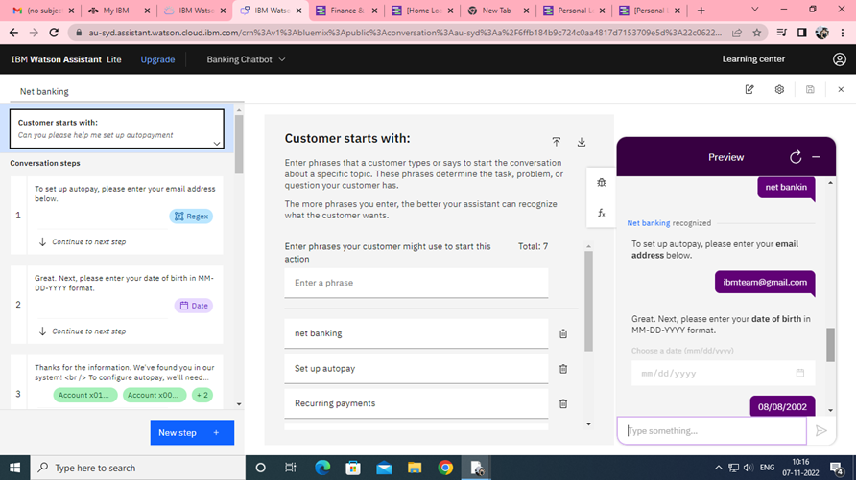

**Creation of Loan Queries**

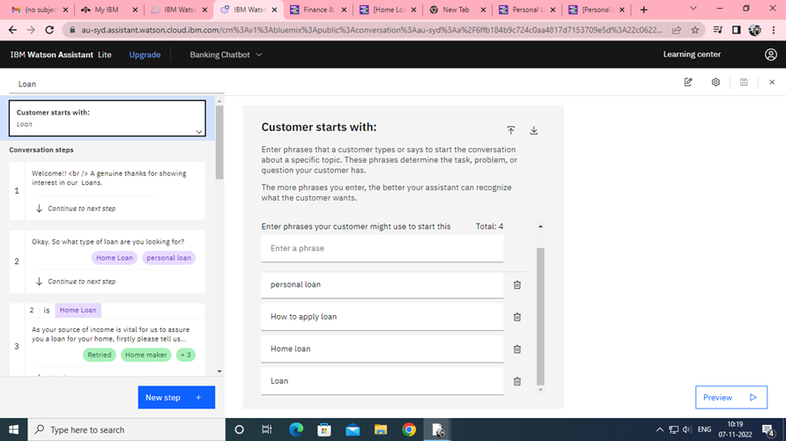

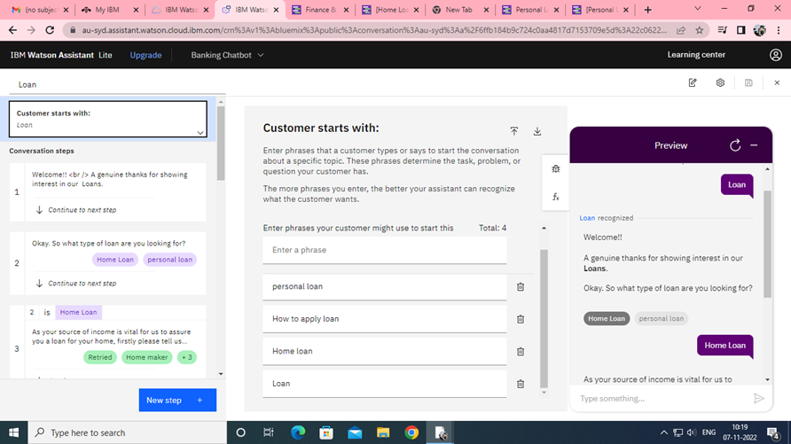

**Note: In this Sprint 2, there is no code needed to create assistant and skills, it purely based on Actions and steps**